VLAN的配置
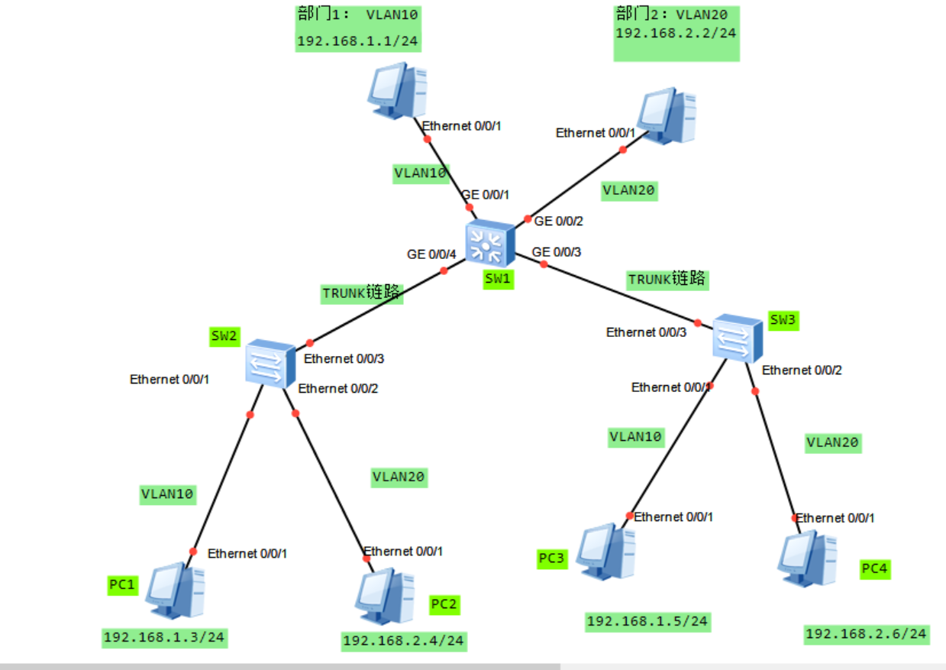

Vlanif 10 ：192.168.1.254/24
Vlanif 20：192.168.2.254/24

<Huawei>system-view
[Huawei]sysname SW2
[SW2]vlan batch 10 20
[SW2]interface Ethernet 0/0/1
[SW2-Ethernet0/0/1]port link-type access
[SW2-Ethernet0/0/1]port default vlan 10
[SW2-Ethernet0/0/1]quit

[SW2]interface Ethernet 0/0/2
[SW2-Ethernet0/0/2]port link-type access
[SW2-Ethernet0/0/2]port default vlan 20
[SW2-Ethernet0/0/2]quit

[SW2]interface Ethernet 0/0/3
[SW2-Ethernet0/0/3]port link-type trunk
[SW2-Ethernet0/0/3]port trunk allow-pass vlan 10 20
[SW2-Ethernet0/0/3]quit
system-view
vlan batch 10 20
interface Ethernet 0/0/1
port link-type access
port default vlan 10
quit

interface Ethernet 0/0/2
port link-type access
port default vlan 20
quit

interface Ethernet 0/0/3
port link-type trunk
port trunk allow-pass vlan 10 20
[SW2-Ethernet0/0/3]quit

<Huawei>system-view
[Huawei]sysname SW3
[SW3]vlan batch 10 20
[SW3]interface Ethernet 0/0/1
[SW3-Ethernet0/0/1]port link-type access
[SW3-Ethernet0/0/1]port default vlan 10
[SW3-Ethernet0/0/1]quit

[SW3]interface Ethernet 0/0/2
[SW3-Ethernet0/0/2]port link-type access
[SW3-Ethernet0/0/2]port default vlan 20
[SW3-Ethernet0/0/2]quit

[SW3]interface Ethernet 0/0/3
[SW3-Ethernet0/0/3]port link-type trunk
[SW3-Ethernet0/0/3]port trunk allow-pass vlan 10 20
[SW3-Ethernet0/0/3]quit

<Huawei>system-view
[Huawei]sysname SW1
[SW1]vlan batch 10 20
[SW1]interface GigabitEthernet 0/0/1
[SW1-gigabitEthert 0/0/1]port link-type access
[SW1-gigabitEthert 0/0/1]port default vlan 10
[SW1-gigabitEthert 0/0/1]quit
[SW1]interface GigabitEthernet 0/0/2
[SW1-gigabitEthert 0/0/2]port link-type access
[SW1-gigabitEthert 0/0/2]port default vlan 20
[SW1-gigabitEthert 0/0/2]quit
[SW1]interface GigabitEthernet 0/0/3
[SW1--gigabitEthert 0/0/3]port link-type trunk
[SW1--gigabitEthert 0/0/3]port trunk allow-pass vlan 10 20
[SW1-gigabitEthert 0/0/3]quit
[SW1]interface GigabitEthernet 0/0/4
[SW1--gigabitEthert 0/0/4]port link-type trunk
[SW1--gigabitEthert 0/0/3]port trunk allow-pass vlan 10 20
[SW1-gigabitEthert 0/0/4]quit
[SW1]interface vlan 10
[SW1-Vlanif10]IP address 192.168.1.254 24
[SW1]interface vlan 20
[SW1-Vlanif10]IP address 192.168.2.254 24

配置主机的IP地址、子网掩码、网关
IP地址网段 | 子网掩码 | 网关
192.168.1.0/24 | 255.255.255.0 | 192.168.1.254
192.168.2.0/24 | 255.255.255.0 | 192.168.2.254

